**EQUIPMENT IDENTIFICATION INFORMATION**

**Lab Name/PI:**

**Lab/Owner Location:**

**Building:**

**Floor:**

**Room No.:**

**Power supply to this device**

**Normal Power Emergency Power**

**Electrical Power Circuit ID# Voltage**

**Emergency Contacts**

**Name: Phone:**

**Name: Phone:**

**Name: Phone:**

For general inquiries about a PSOM building, please scan below or visit our webpage at

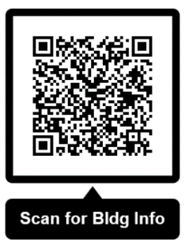[**https://www.med.upenn.edu/spo/buildings-and-administrators.html**](https://www.med.upenn.edu/spo/buildings-and-administrators.html)or email [**PSOMSPO-Ops@lists.upenn.edu**](mailto:PSOMSPO-Ops@lists.upenn.edu)

**Space Planning & Operations**

**Operations & Engineering**

**Perelman School of Medicine**

**215-898-8760**